|  |
| --- |
| C:\A LAPTOP BACKUP DELL 020611\A BELWITH\A SR TECHNOLOGY\SR Websites\LOGOS\SecuRemote-Smart-App-Icon-5 Nicole\securemote-smart-logos\SecuRemote-Smart-LogoBB.png |

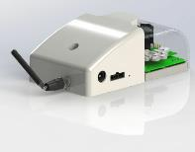

**GDO Controller Module**

**Model# SRG232 Instructions (EN) Rev. 16**

**For use only with garage door operators complying with UL 325, manufactured after January 1, 1993. And utilize photoelectric safety sensors.**

**Warning: To reduce the risk of injury to persons-Only enable the unattended operation closing function feature when installed with sectional door.**

**Supplemental instructions for adding Unattended Operation Control module to an existing Garage Door Operator.**

****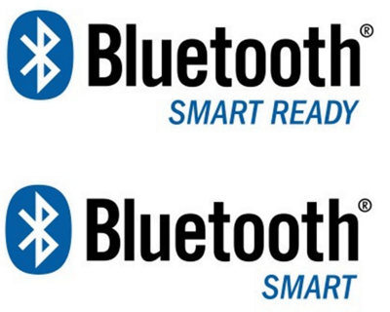

**LISTED ACCESSORY E467287**

|  |
| --- |
|  |

Table of Contents:

2 SRG232 SecuRemote™ Smart Overview: 3

2.1 Installation 3

3 Safety: 4

4 System overview: 5

4.1 LOCAL: 5

4.2 REMOTE: 5

4.3 SecuRemote™ REMOTE: 5

4.4 Compatibility test: 6

4.5 Signal Diagram: 6

4.6 Module mounting considerations: 7

4.6.1 Signal: 7

4.6.2 Safety: 7

4.6.3 Identification: 7

4.6.4 Wiring and Power: 8

5 Install Module / Sensor: 9

6 Mobile app installation: 11

6.1 Approved Devices: 11

7 Maintenance and factory reset: 12

8 Cellular Broadband Network 13

9 Authority 14

10 Acknowledgements: 15

10.1 FCC and IC: 15

10.2 Underwriters Laboratory (UL): 15

11 Version List of Instruction and Software: 16

12 Disclaimer 16

13 Glossary 16

# SRG232 SecuRemote™ Smart Overview:

* SecuRemote™ (SR) Smart adds the capability to control most Garage Doors remotely by allowing iOS and or Android™ mobile devices to control a Garage Door from almost anywhere. There is no need to install special routers. The ***Local*** communication operates line of site directly with these devices using encrypted Bluetooth™ Low Energy. ***Remote*** communication uses an encrypted Cellular connection. This eliminates the typical reliability issues with setup, configuration, and maintenance of home networks. See Section 4.4 for Garage Door Operator compatibility test.

## Installation

Step 1: Install the SRG232 module and hardware to an existing Garage Door Operator (GDO), the SRG232 Module is powered by 110 Volt A/C. No batteries are required

Step 2: Download the free application to your mobile device and review app instructions for functionality

Tools Required:

Tool Letters will appear in figures

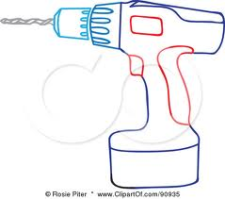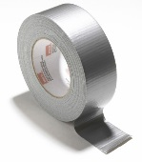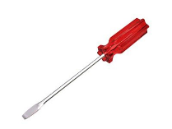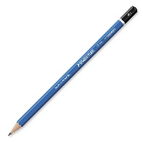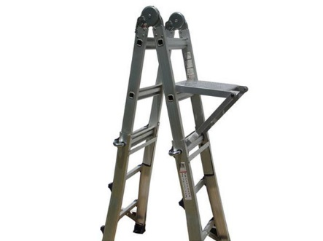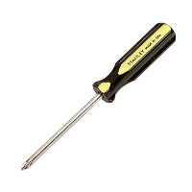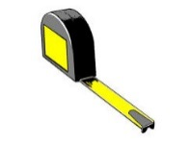

Above Tools as needed

Ladder

Tape

Flat Blade screwdriver

Pencil

Phillips screwdriver

Drill

Hammer

Tape measure

A

B

C

D

Wire stripper

E

# Safety:

***************************************************************************************************WARNING! This operator system is equipped with an unattended operation feature.

The door could move unexpectedly.

***************************************************************************************************

This device has been designed and tested with SAFETY as the first priority. Current garage door operators generally are used when the user[s] have a line-of-sight to the garage door. It is important that all the users and persons traveling through the garage space have knowledge of the operation of this device.

* DO NOT install on one-piece or swinging doors.
* This product is designed for use on residential sectional doors ONLY.
* For use only with on garage door operators complying with UL325, manufactured after Jan 1, 1993 that utilize photoelectric SAFETY sensors. Any modifications may cause serious injury.
* DO NOT block the LED lights or disable the audible warning beeper.
* Please familiarize all persons that may use the garage door operator of this devices operation.

***************************************************************************************************

SRG232 Features:

* AUDIBLE movement warning beeper is activated for 5 seconds prior to door close movement after Remote Signal is received by module.
* LED lighting provides visual warning before door closes.
* ***Unattended operation*** monitor: If the door fails to respond to remote command, two (2) times, reset the module by pressing the local actuation ‘doorbell’ button to reset the module operation. This will resume proper remote operation.
* All wireless signals to and from the SRG232 module are secure.
* ALL power and device failures will not allow garage door to OPEN /CLOSE unexpectedly.
* All materials and functionality comply with UL325 safety standards.
* Software for mobile devices and SRG232 are capable of being upgraded “over the air”.
* Does not interfere with any ***Current*** existing control devices.
* 110 volt A/C Class 2 power supply rated for continuous duty.

# System overview:

## LOCAL:

Current Garage door systems typically use ‘doorbell’ type or console momentary contact button installed in a protected area that allow for the user to observe and control the OPEN/CLOSE functions of the movable garage door. This is a LOCAL type of control. They are often wired to the garage door operator directly.

## REMOTE:

Current, In addition to the LOCAL control as described in 4.1 the typical garage door operator is designed to operate with a wireless REMOTE device. This device is available as a Keyfob, a Keypad, or as an accessory in many automobiles. They communicate with a low frequency radio wave to a electronically matched Garage Door Operator. The range is generally about 100 ft. (30 meters).

## SecuRemote™ REMOTE:

New, The SRG232 device adds two new methods to the REMOTE functionality. The SecuRemote™ module adds the ability to OPEN/CLOSE the door via a Smart mobile device. (See approved device list in section 6.1). The SecuRemote™ uses secure Bluetooth™ signals when the mobile device is within a 150 feet (45 meters) OR uses the phones Cell signals to communicate to the Garage Door operator using secure communications. The range of the Cellular communication is only limited to the ability of the mobile devices cellular connectivity. If the mobile device can receive a text message then the SRG232 is capable of controlling the garage door. The door Status and Audit trail is also available for viewing on the mobile device. The mobile device SecuRemote™ applications help menu has further details regarding these.

Testing the ability to communicate to the mobile device is confirmed by placing the mobile device near the SRG232 antenna and observing the signal strength meter on the mobile device.

The REMOTE control feature selection of Bluetooth™ or Cellular is displayed on the Smart mobile device during transmission. This switching is seamless to the user. The SecuRemote™ application monitors the signal strength and makes the appropriate connection.

NOTE: When operating the door using the mobile device, avoid multiple rapid button presses. The communication response speed to the door is limited to the signal processing time of the cellular signal. For safety purposes, if the button on the mobile device is pressed multiple times rapidly the system will no longer allow the REMOTE operation. A warning dialogue box will appear on the mobile application. The app needs to be restarted after seeing this dialogue box. After two commands [OPEN or CLOSE] are sent to the SRG232 and there is no response confirming proper operation. The SRG232 will stop receiving commands. The SRG232 will need to be reset by pressing the local doorbell or console button locally.

If installing in a location where multiple persons have access to the garage space it is important to make them aware of the features of this device.

## U+26A0**Compatibility test**:

Before performing this test, check that there are no obstructions in the path of the Garage Door.

The SRG232 does not fit ALL Garage Door Operators. BEFORE installing test the existing Garage Door Operator [GDO] by temporarily shorting across the connections of the Door Button switch with a paperclip. If the door moves the SRG232 will function properly. If not, the door button or console is electronically matched to the Garage door Operator and will not operate properly with the SRG232. Do not short to ground or apply any other power to the terminals.

## Signal Diagram:

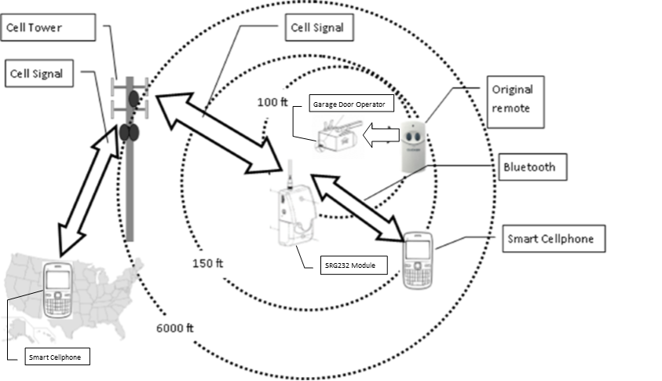The figure below details how the control signals are propagated to and from the Garage Door Operator.

Internet

## Module mounting considerations:

### **Signal:**

The SRG232 uses a ‘screw on’ antenna, this antenna receives and transmits Cellular signals. Consider the cellular signal strength when installing the SRG232 control module. A mobile device (cellphone) strength meter can be used to check the garage space for best signal. When mounting, position the module with the antenna pointing UP. Note: The cellular signal utilizes SPRINT™ as the carrier. The Bluetooth™ signal antenna is internal to the SRG232.

### **Safety:**

The SRG232 has a flashing strobe LED, an audible beeper, and a WARNING label. The LED flashes and the audible beeper activates when the SRG232 receives a CLOSE signal from a mobile device running the SecuRemote™ application. Mount the SRG232 device in a visible location. Adjacent to the ‘doorbell’ button or console makes an ideal location. In the event the door is closing and needs to stop, press the ‘doorbell’ button to cancel the motion. Place the supplied WARNING label in a visible location near the ‘doorbell’ button.

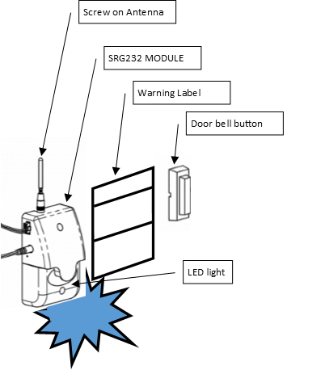

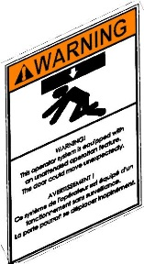

Flashing Strobe LED

### **Identification**:

The serial number information and UL information is printed on a label on the rear surface of the SRG232. Install the SRG232 in a location which will allow easy access to the mounting screws.

### **Wiring** **and** **Power**:

The module requires power from the plug in power supply. The Sensor has two wires connection. The operation ‘doorbell’ button wires need to be connected either to the Garage Door Operator or the ‘doorbell’ switch. Consider the layout of each connection before installing the module. Route wires to avoid pinch areas. The figure below shows a general overview of the installation.

MAGNETIC SENSOR

MAGNETIC SENSOR WIRE

CONTROL WIRE TO SRG232

EXISTING CONTROL WIRE TO ‘DOORBELL’ BUTTON

EXISTING ‘DOORBELL’ BUTTON

EXISTING GARAGE DOOR OPERATOR

POWER SUPPLY [PLUG INTO 110 V A/C]

POWER SUPPLY WIRE [PLUG INTO MODULE]

SRG232 MODULE [ANTENNA POINTING UP]

WARNING LABEL

GARAGE SPACE

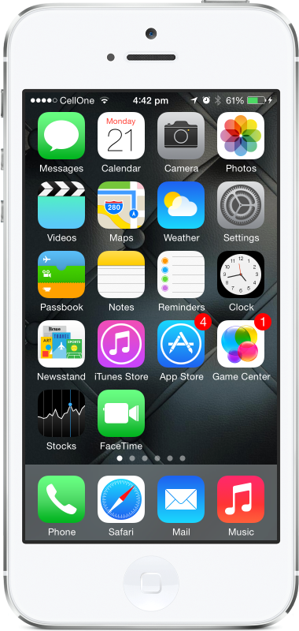

Smartphone set-up

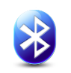

Bluetooth “ON”



Look for good cell signal on mobile device in Garage Space.

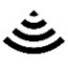

Turn OFF Wifi. NOT required.



# Install Module / Sensor:

TURN ALL POWER **OFF** TO GARAGE DOOR OPERATOR BEFORE ATTEMPTING INSTALLATION

The module and sensor performs two functions:

1. 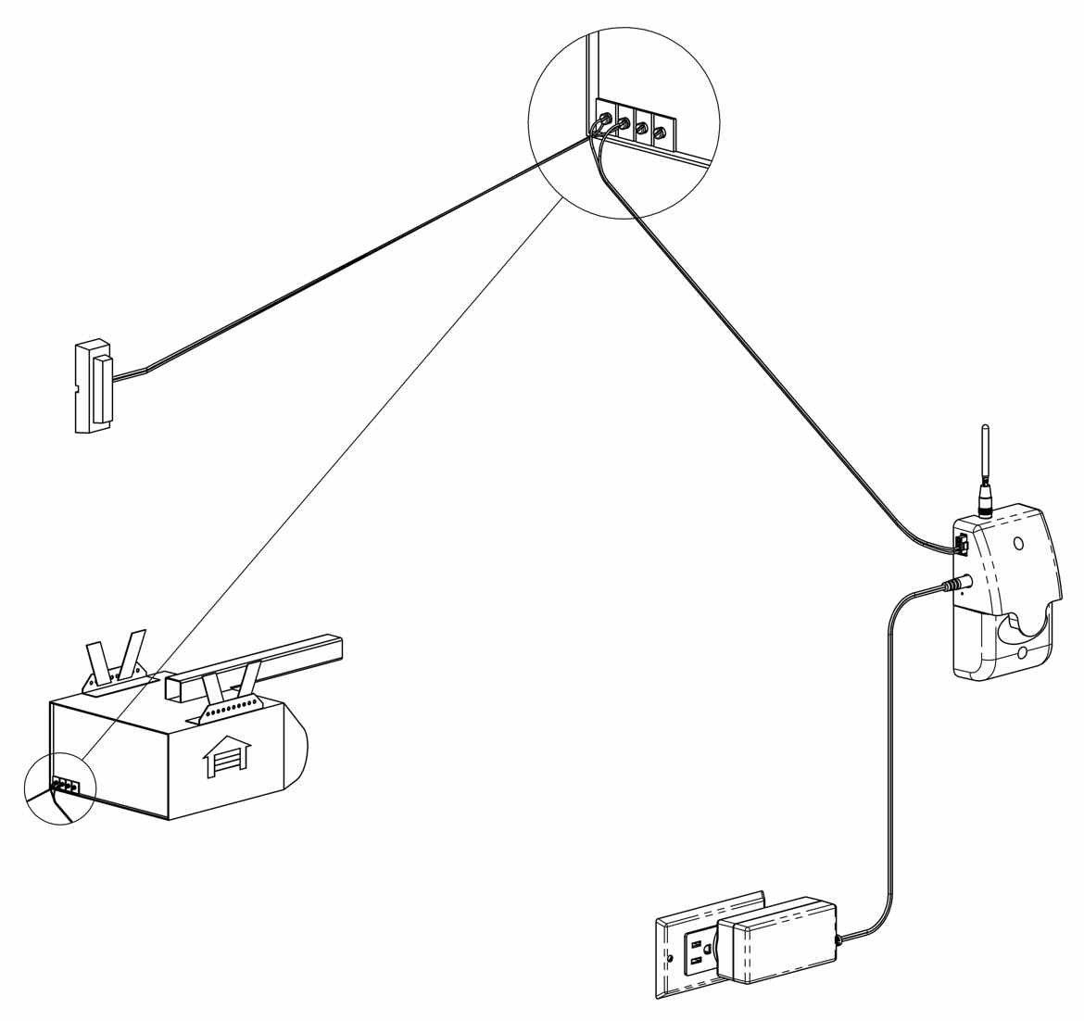The MODULE activates the console or Garage OPEN/CLOSE “doorbell” button. The SRG232 module duplicates the ‘doorbell’ button press.

Close up of Garage Door Operator connection. Refer to ***Current*** operator instructions for detail connections.

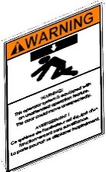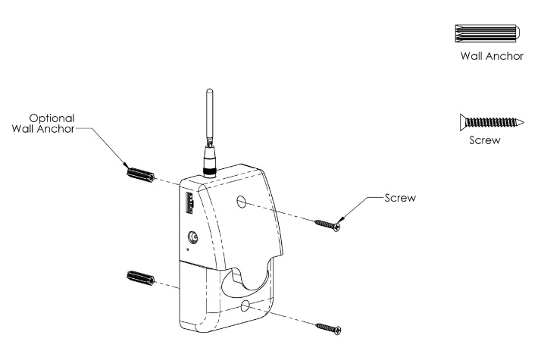

Install user WARNING label

Reset button. Use paperclip ONLY. ALL USERS WILL BE ERASED See Section 7

**New** Control wire to SRG232

**New** SRG232 module.

Align Antenna as shown.

***New*** Wire to Sensor See Section 2)

C

D

D

Mount the SRG232 module with screws as shown. For safety purposes, Place the module where it is visible to persons inside the garage area.

QR and ID labels on back of module. See instructions for use details.

***Current*** “OPEN/CLOSE button

**New** Plug-in power supply use 110V A/C outlet

**New** Power supply wire to SRG232

***Current*** Garage Door Operator.

1. The SENSOR will monitor the garage door position. Note: The location marker sensor uses a rare earth permanent magnet. Please place this sensor carefully as shown. [ place location marker sensor within ¾” and no further than 2 ¼” from the magnet on the top of the door. The SRG232 Module uses this sensor assy to report and control the door OPEN/CLOSE operations.



******* DO NOT ATTEMPT TO OPERATE THE DOOR WITHOUT THE SENSOR. *******

The sensor wire shares the control wire ‘plug’ that snaps into the SRG232 module. The wire leads may be attached either way to sensor. The wire length should be considered when installing the SRG232 module placement. Avoid placing wire across the wheel tracks of the garage door.

****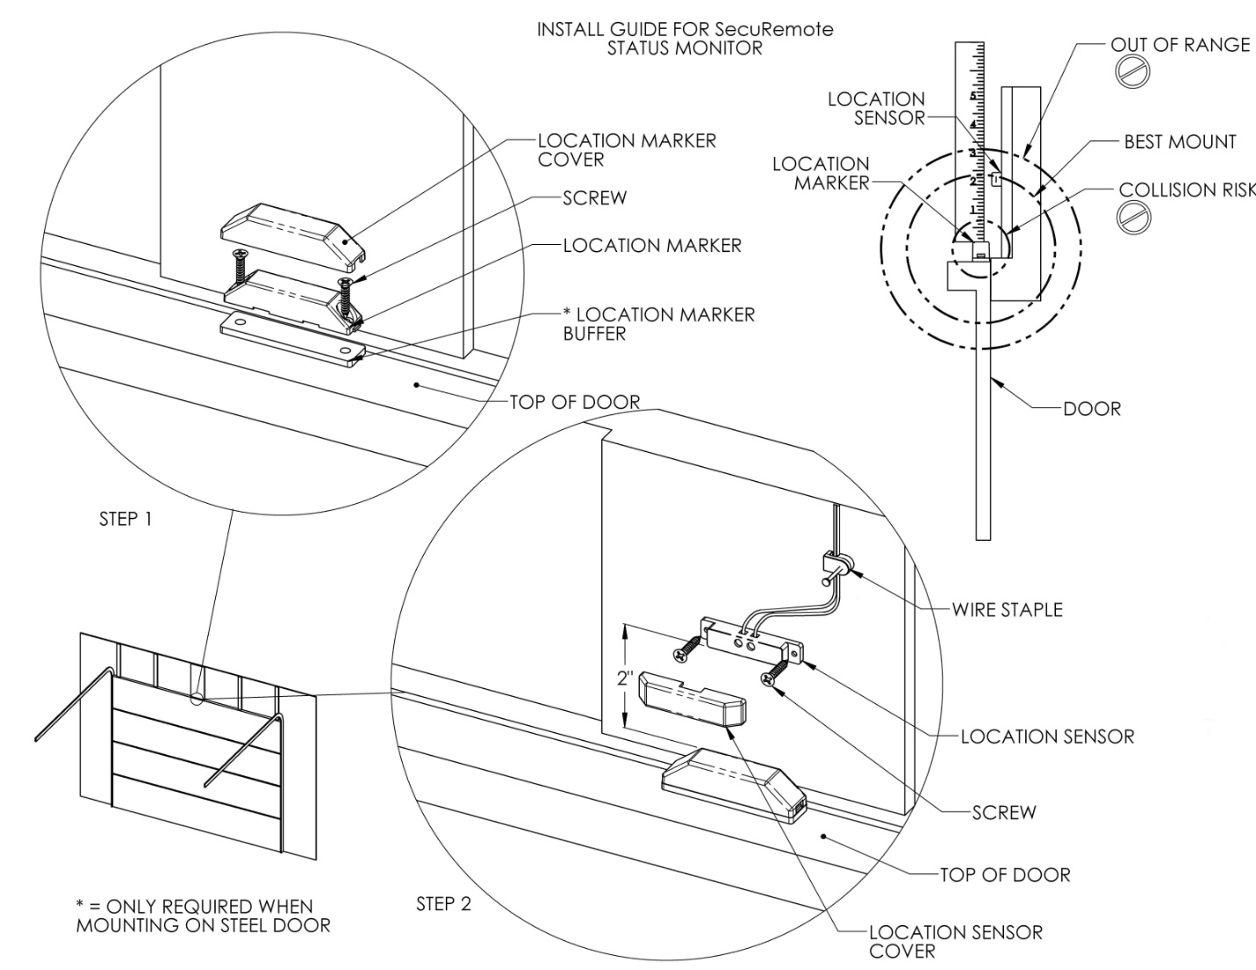

***New*** If wire needs to be shorter, cut and strip wire, CONNECT TO LOCATION SENSOR

***New*** Wire to module

See Section 1)

B

E

D

A

# Mobile app installation:

## Approved Devices:

Works with iPhone™ 4S & up, iPod™ 5th generation & up, iPad™ mini, Android™ smartphone, Galaxy Note 4™, with OS version 4.3 & above with BLE support.

For iOS devices: Download SR Smart™ App from Apple Store™ for iOS Devices.

1. Turn Bluetooth ‘ON’ [use setting icon]
2. Launch the SR Smart™ App.
3. Turn power ON for the garage door operator. Operate with existing “doorbell” button.
4. The SRG232 device ID now needs to be added to the Apple™ device.

The SR Smart™ device software allows for entry by either of these two (2) methods. 1) Scan the QR Code [this may require downloading QR reader software application] 2) Type in the information from the label on the mobile device. This will then automatically allow the mobile device to go online and register the SRG232 module on SR Portal. NOTE 1: These labels are placed on the rear (wall side) of the module. [see figure section 5] They contain secure [private] information and should be protected from casual viewing.

1. Add a valid email ID and PASSWORD to create online account on SR Portal.
2. This will create a User Account on SR Portal.
3. With successful registration and account creation, the app will connect to the SRG232 module automatically.
4. A Blue LED on the module will blink until the Bluetooth™ is connected.
5. Press “Status” button on home screen to learn the status of GDO.
6. Press “OPEN” button on home screen to OPEN the Garage Door.
7. Press “CLOSE” button on home screen if CLOSE the Garage Door.
8. 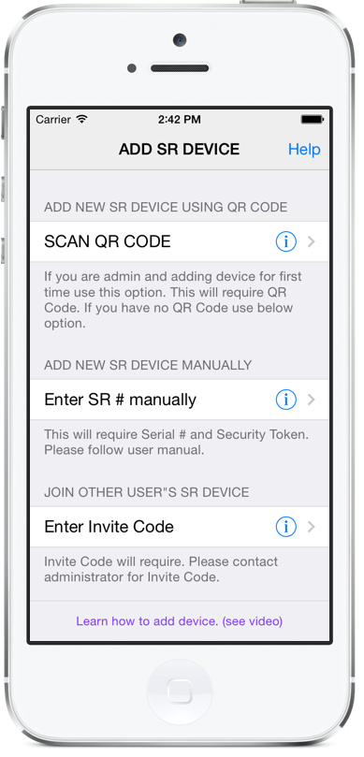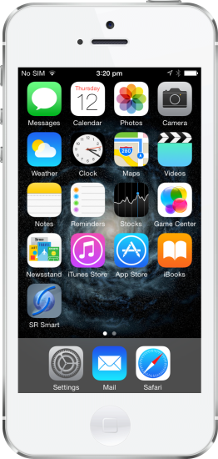Instructions are included with application for customization. (see help section)

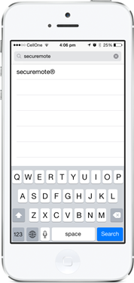

SR Smart

Learn SRG232 into the phone application

Download / Install / Run Application

o

For Android™ devices: Download SR Smart™ App from Play Store™ for Android™ Devices.

1. Turn Bluetooth ‘ON’ [use gear icon in taskbar]
2. Launch the SR Smart™ App.
3. Turn power ON for the garage door operator. Operate with existing “doorbell” button.
4. The SRG232 device ID now needs to be added to the Android™ device.
5. The SR Smart™ device software allows for entry by either of these two (2) methods. 1) Scan the QR Code [this may require downloading QR reader software application] 2) Type in the information from the label on the mobile device. This will then automatically allow the mobile device to go online and register the SRG232 module on SR Portal.

NOTE 1 : These labels are placed on the rear (wall side) of the module. [see figure section 5].They contain secure [private] information and should be protected from casual viewing.

1. Add a valid email ID and PASSWORD to create online account on SR Portal.
2. This will create a User Account on SR Portal.
3. With successful registration and account creation, the app will connect to the SRG232 module automatically.
4. A Blue LED on the module will blink until the Bluetooth™ is connected.
5. Press “Status” button on home screen to learn the status of GDO.
6. Press “OPEN” button on home screen to OPEN the Garage Door.
7. Press “CLOSE” button on home screen if CLOSE the Garage Door.

# Maintenance and factory reset:

It is recommended that the user test the safety features of the SRG232 once per year. These instructions do not replace the existing Garage Door Operator maintenance suggestions. These are ‘in addition to” the existing garage door operator instructions.

Labels / Warning placement: Check that the WARNING label is located in clear view next to the operating doorbell or console switch AND is readable. If not, contact the manufacturer to obtain a new one.

User Functional / Operational Tests:

***Set-up:***

1. Before testing, the user should clear all obstructions from the door path. Remove any pets or other obstructions that may inhibit the door movement or become entrapped.
2. For this test, the user should be situated in the garage space with a clear view of the SRG232 module AND current garage door.
3. The user should insure the original factory OPEN / CLOSE doorbell button or console switch assembly is within reach.
4. The user should have the authorized mobile device with the SecuRemote™ application installed available.

***Existing garage door operational test:*** The user should refer to the existing Garage Door Operator instruction for interval and procedures.

***Warning systems****: [All the following tests and observations should be conducted by the user].* The door should be allowed to complete the OPEN or CLOSED cycle. The location sensor requires a switching input when the door is CLOSED. If door is stopped midway [neither OPEN nor CLOSED] the sensor cannot detect the movement. The SRG232 will therefore ‘read’ the door status as OPEN on the mobile app.

1. Flashing strobe LED: Start the application on the mobile device. Observe the current door position. If door status shows OPEN and the door is OPEN next press the ‘close’ button on the mobile application screen. The application will send the signal either through Bluetooth or Cellular. When the SRG232 receives the signal the Strobe LED light will flash for approximately five (5) seconds. After the strobe LED stops flashing the door will begin CLOSING.
2. Emergency STOP: Repeat step (1) during the CLOSE operation, press the ‘doorbell’ button. The door should stop and reverse the same way it normally would react as described in the existing garage door operator manual.
3. Beeper: Start the application on the mobile device. Observe the current doors position. If door status shows OPEN and the door is OPEN then press the close button on the mobile application screen. The application will send the signal either through Bluetooth™ or Cellular. When the SRG232 receives the signal the Beeper will sound loudly for approximately five (5) seconds. After the beeper stops the door will begin CLOSING.

***Reset the system:***

A small hole as shown [Fig in Section 5], in the module is provided for the reset button. This button will restore the SRD232 back to the factory settings. Depressing this button will erase all the users from the SRD232. It will not erase the device from the SecuRemote™ Internet server. Use a paperclip only for depressing this button. Excessive pressure may damage the control board.

***Internal parts:***

There are no serviceable parts inside this system. The power supply uses an automatic reset for power disruption.

# Cellular Broadband Network

Just like any smartphone, this device uses a cellular broadband communication (also referred to as a mobile network) module that allows it to maintain a direct and permanent connection with the *SecuRemote*™ portal on the cloud. This communication is encrypted and it is accomplished through a private mobile network provided by SPRINT™ or another mobile network provider that may be cited in the product documentation or user instructions.

Just like any other mobile device the broadband communication requires cellular coverage. The mobile device uses a signal strength meter. These are typically on the top task bar of the mobile device. The signal strength is shown typically as ‘bars’ or a series of ‘dots’ this measures the cellular signal strength. The more ‘bars’ or ‘dots’ indicates stronger signals. Note: The SRG232 SPRINT as the signal carrier. If SPRINT does not provide text message service in the garage space the Remote operation will not work properly.

To Check for SPRINT cellular coverage in your area visit:

<https://coverage.sprint.com/IMPACT.jsp>?

# Authority

Contains module listed under FCC:2AEHJSRU232

This SRG232 module complies with Part 15 of the FCC rules.

Operation is subject to the following two conditions.

1) This Device may not cause harmful interference and

2) This device must accept any interference received. Including interference that may cause undesired operation.

++++++++++++++++++++++++++++++++++++++++++++++++++++++++++++++++++++++++

This SRG232 module contains a module SRU232 that has been tested and found to comply with the limits for a class B digital device, pursuant to part 15 of the FCC rules. These limits are designed to provide reasonable protection against harmful interference in a residential installation. This equipment generates, uses a can radiate radio frequency energy and if not installed and used in accordance with the instructions, may cause harmful interference to radio communications, however, there is no guarantee that interference will not occur in particular installation. if this equipment does cause harmful interference to radio of television reception, which can be determined by turning the equipment off and on, the user is encouraged to try to correct the interferences by one or more of the Following measures:

• Reorient or relocate the receiving antenna.

• Increase the separation between the equipment and the receiver.

• Connect the equipment into an outlet on a circuit different from that to which the receiver is connected.

• Consult the dealer or an experienced radio/TV technician for help.

In order to maintain compliance with FCC regulations, Operation with non-approved equipment is likely to result in interferences to radio and TV reception. The user is cautioned that changes and modifications made to this module without the approval of manufacturer could void the user’s authority to operate this equipment.

# Acknowledgements:

Apple™, App Store™, iPhone™ and iPad™ Apple logo are trademarks of Apple™ Inc.,

Droid logo, Android™, Play store™ Galaxy Note 4™ are registered trademarks of Google™ Inc.

SecuRemote™ is a trademark of Belwith™ Products.

All are registered in the U.S. and other countries.

SRG232 utilizes Sprint™ M2M data services under license to Delphian™ Systems LLC.

Delphian™ logo is a trademark of Delphian Systems LLC.

Any screenshot images are property of their respective owners.

Copyright 2015. All rights reserved. Patents pending.

## FCC and IC:

Contains FCC:QIPPHS8-P and 2AEHJSRU232

Industry Canada, IC ID:20053-SRU232

Certified / tested by Sprint™ for proper network connectivity.

## Underwriters Laboratory (UL):

File# E467287

Product also listed in Canada.

The SRG232 module is manufactured without the use of lead or other environmental hazardous substances.

***************************************************************************************************

Declaration of environmental compatibility for supplied products:

We hereby declare to our best present knowledge based on declaration of our suppliers that this product does not contain the following substances which are banned by Directive 2002/95/EC (RoHS) or if present, a maximum concentration of 0.1% by weight in homogeneous materials for:

* Lead and lead compounds
* Mercury and mercury compounds
* Chromium (VI)
* PBB (polybrominated biphenyl) category
* PBDE (polybrominated biphenyl ether) category

And a maximum concentration of 0.01% by weight in homogeneous materials for:

Cadmium and cadmium compounds

# Version List of Instruction and Software:

These instruction apply to the version(s) of software as below. Software versions are subject to change.

Garage Door Operator Application Software version, BLE: V01.01.09 Garage Door Operator Stack S310 nRF51422 Software version, BLE: V01.01.01 Garage Door Operator boot loader Software version, BLE: V01.01.01 Garage Door Operator Software version, Network: V01.01.03 Garage Door Operator Sprint version: REVISION 02.10.0 Smartphone application version: V01.00.20

Version 12 GM change Header information to GDO 3/24/2015

Version 13 GM add UL logo front cover 3/25/2015

Version 14 GM added Glossary 3/26/2015

Version 15 GM/JV adjusted all data 3/27/2015

Version 16 GM Added FCC numbers 4/21/2015

# Disclaimer

All information contained in this manual is current to production date of the SRG232, subject to software conditions.. SRG232 has been tested to comply with all applicable safety standards in force as of the date of manufacture. Any alteration of this device many cause injury and/or void warranty. Complies to Underwriters Lab UL 325 Ed. 6 - Standard for Door, Drapery, Gate, Louver, and Window Operators and Systems. Copy of this instruction is also available in a French version online at: [www.delphiansystems.com](http://www.delphiansystems.com)

# Glossary

GDO = Garage Door Operator, Specifically referring to the existing installed operator.

SecuRemote™ = Secure Remote, Is a communication and control system. The Software resides in a multitude of devices and physical servers this accessible also through the Internet.

Unattended Operation = When the user can observe the garage door this is ‘attended operation’. If the user is not in visual range of the garage door AND can cause it to OPEN/CLOSE this is called ‘Unattended Operation’.

Line of Sight = This term is used when the user can observe the garage door movement.

Mobile device = Any portable device that can support BLE and Cellular communication. Typically, Smart phone, Tablets, Laptops with cellular support.

Flashing Strobe = The module has two LED light assemblies that turn ON and OFF to warn the users that the module has received a signal from a remote location.

Beeper or buzzer = The module has an audible alarm that works in conjunction with the flashing strobe.

Location Marker = This is a magnetic sensor assembly that mounts on the top of garage door. Its purpose is to send signal via wires to the module to report the location [closed]of the garage door.

QR tag = A Square identification marking [similar to a bar code] that is encrypted with data that can be read using camera with QR application installed on smartphones.

Keyfob = A small handheld GDO wireless communication device that typically installs on a key ring. Slightly larger versions are available that typically are attached to an automobiles sun visor.

UL = Underwriters Laboratory. UL is a global independent safety science company with more than a century of expertise innovating safety solutions from the public adoption of electricity to new breakthroughs in sustainability, renewable energy and nanotechnology. Dedicated to promoting safe living and working environments, UL helps safeguard people, products and places in important ways, facilitating trade and providing peace of mind.

SIG = Special Interest Group. This organization certifies the device complies to the standards for safe operation of Bluetooth.

Over-the-air = Software is often upgraded as bugs and fixes are revealed through operation of the device(s). This allows the engineers to install this new software without having to ‘uninstall and re-install’ the software using cables.

***Current*** = Current refers to the existing mechanisms, wires, switches, etc. for the GDO.

***New*** = This term refers to the parts and accessories supplied and used in this kit.

SR portal = Secure Remote Internet Portal is a secure server for registration of the SecuRemote® devices and the users. It is accessible through computers, mobile devices that have Internet access.

SR Smart = This is the mobile app acronym. This app is the identification for the SecuRemote™ mobile software.

IC = Industry Canada performs similar functions as the FCC does in the United States for Canada.